The School District City of Erie, PA

February 2025

Bidder Must Deposit With

Bid – **CERTIFIED CHECK** Or

BID BOND 5% of Total Bid

**BID ON –** Anatomage Table / Associated Accessories and Training

## The Board of Directors

of the School District

of the City of Erie, PA

Gentlemen:

We, the undersigned, propose to furnish and install the following **BID on Anatomage Table / Associated Accessories and Training:**

DOLLARS ($_____________)

Bids shall be sealed and endorsed on the envelope, or on the subject line on electronic submissions, **“Anatomage Table / Associated Accessories and Training”** and delivered to School District of the City of Erie, Administration Building,1910 Sassafras Street, Erie, PA 16502 Board Secretary Office, ATTN: BIDS, by February 25th, 2025 by 11:00 am. Bids shall be delivered either in person, via USPS, a contract carrier such as UPS, FedEx, etc., or via electronic submission to bids@eriesd.org.  Late bids will be rejected.  Bids will be opened utilizing an online format on February 25th, 2025 at 11:30 am. Award of bid may be made at the regular meeting of the Board onMarch 12th, 2025 at 6:00 pm.

The School District will conduct the bid opening utilizing an online format at the date and time identified above. The School District will provide interested proposers with a link to participate in the bid opening. If an interested proposer requires reasonable accommodations to participate in an online format bid opening due to a disability, if the interested proposer wishes to participate in the meeting but does not have internet access, or if a member of the public wishes to view the opening electronically, contact Neal Brokman, Assistant Superintendent, at [nbrokman@eriesd.org](mailto:nbrokman@eriesd.org).

The Board of School Directors will consider accepting the bid of the lowest responsible bidder meeting specifications, kind, quality and material being equal, but shall have the right to reject any and all bids and to waive defects in form. The Board is not obligated to accept the lowest or any other bid.

Respectfully submitted:

The School District City of Erie, PA

***Brian J. Polito, CPA 1910 Sassafras Street, Erie PA 16502***

***Superintendent of Schools***

# GENERAL CONDITIONS

Bids shall be submitted on the Bidding Blank attached hereto, and should be submitted through the means identified on the Bidding Blank.

No bids will be entertained unless accompanied by a deposit, as a **CERTIFIED CHECK or BID BOND** in the amount of five per cent (5%) of the total bid, made payable to The School District City of Erie and enclosed in the envelope containing the bid.

No bid received can be withdrawn prior to the close of the regular meeting of the Board of School Directors next succeeding the opening of the bids. Bidder agrees that the School District of the City of Erie shall have up to sixty (60) days to accept or reject the bid and bidder agrees that the bid quote shall remain open for that period. The Board of School Directors may reject any bid, or portion of any bid, for any reason or no reason.

The special attention of the bidders is directed to the fact that no claims for relief on account of mistakes or omissions in the bidding will be considered and the contractors will be held strictly to their bids, or, alternatively, and at the sole discretion of the Board of School Directors, their deposit may be forfeited. In addition to other remedies available to the School District, the deposit shall be forfeited if the successful bidder fails to execute an agreement or perform as required.

**Standard of Quality**: The specific mention of a manufacturer’s name shall be understood to indicate a standard of quality or design, and not as limiting competition thereon or excluding other goods equal in every respect to the materials or goods specified in the opinion of the Controller or his designee. If you do not bid on our specifications as listed, please fill in manufacturer’s name and model number of items you intend to furnish as an equal alternate. The Career and Technical Educational Director, or his designee, shall determine, in his sole discretion, whether the alternate item is an approved equal.

Bidders are to submit prices on both the rate and the total. Bidders please indicate length of time prices will remain firm. If a “Rate” is given on an item, a “Total” must be given on the item. Awards may be made item by item and bidders hereby agree to furnish the items awarded to them. All supplies furnished upon the contract not up to specifications will be rejected.

All charges for transportation, freight, express and parcel post are to be paid by the successful bidder. It is understood that the bidder agrees to deliver any items on which bids are accepted.

Completion of contract shall not exceed sixty days after award is made. The successful bidder will be required to execute a contract with the School District if identified as the apparent low bidder. A fully executed contract must be received by the School District prior to final award by the Board of School Directors. The form of the contract is enclosed with this bid packet.

All items to be delivered to the Erie High School. If you have any questions, please contact Jason Burgert, Career and Technical Education Director at 814-874-6225 or [jburgert@eriesd.org](mailto:jburgert@eriesd.org).

**SPECIFICATIONS**

The following specifications are approved by the Board of Directors for purchase or approved equal as approved by the Career and Technical Education Director.

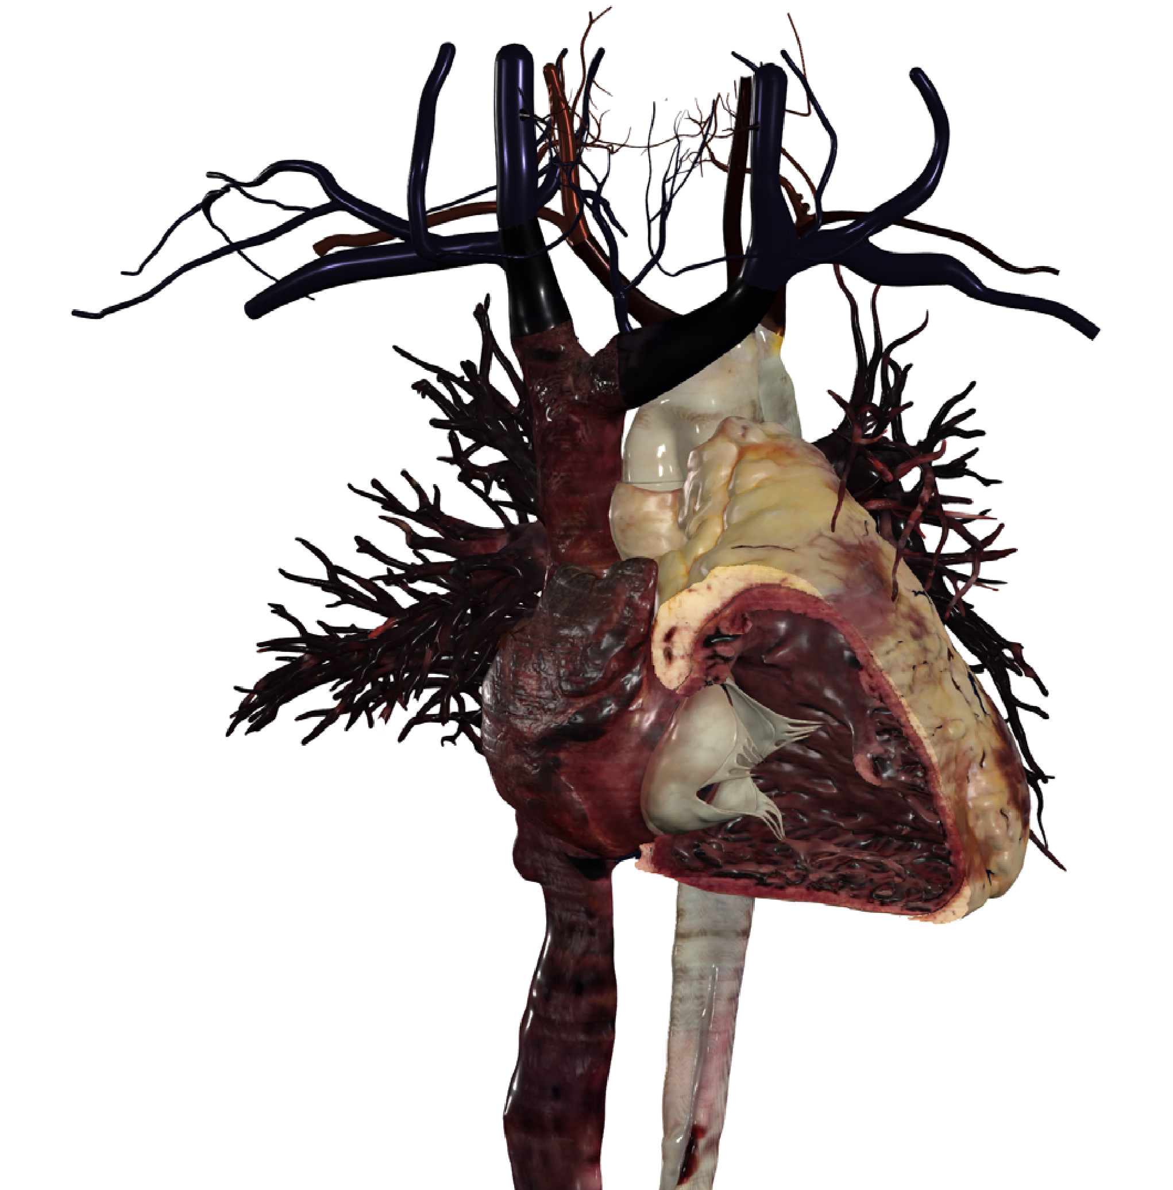**Conceptualize The** Most Difficult Anatomy and Physiology **Concepts With 3D**

# Table of Contents

Introduction................................................................................................................................ **2**

What are 3D digital modeling and simulation of human bodies?................................................... **2**

Challenges in teaching anatomy & physiology............................................................................... **4**

Cardio Vascular System.................................................................................................... **4**

Nervous System Pathways................................................................................................ **5**

Kinesiology........................................................................................................................ **6**

Conclusion...................................................................................................................................... **7**

Visualize Life with the Anatomage Table....................................................................................... **8**

Academic advantages of Anatomage Table 8’s 3D visualization & simulation................... **9**

**“I profess to learn and to teach anatomy not from books but from dissections, not from the tenets of Philosophers but from the fabric of Nature.”**

—William Harvey

Providing the essential knowledge to many medical areas, anatomy beyond a doubt helps students gain significant insights into anatomical variation, its structures, and roles in keeping our bodies alive. As one of the most significant components in gross anatomy is cadaveric dissection, anatomy educators and trainers pay special attention to ensure the accuracy and efficiency of the dissection materials including cadaveric specimens and anatomy models.

In the early 20th century, cadaveric dissection was often used as the main tool for human anatomy discovery & education. Given physical cadavers’ limits, digital cadavers were developed allowing students and trainers to manipulate human bodies without the pressure of making an irreversible mistake.

Recently, an emerging issue around the lack of human specimens and cadavers has raised concerns about the accessibility of learning materials for teaching anatomy. This concern also pushes for a quest to look for technologies that help students to visualize, interact and study human bodies accurately.

What are 3D digital modeling and simulation of human bodies?

Before, 3D anatomy modeling and simulation were utilized as an instrument to supplement lab activities in addition to cadaveric dissection. Gradually, as the technology continues to be innovated, their applications also become more versatile allowing them to resolve visualization challenges that physical cadavers can’t.

One of 3D modeling’s greatest benefits is its ability to provide accurate anatomy that is often taken from real human corpses. Digital reconstruction allows anatomy to be visualized in its original state, unlike human specimens where the tissue on the surface can be damaged and tarnished by chemicals or natural causes.

The terms “modeling” and “simulation” are often used simultaneously but they describe different processes. 3D modeling is a process in which raw data from human specimens or imaging files (MRI/CT) is extracted then reconstructed into 3D modeling of the organs, while the simulation refers to how the modeling process is executed. When it comes to anatomy visualization, simulation tools replicate a certain set of actions or behaviors that a human body produces.

For example, a heart’s anatomy can be digitally modeled to examine the internal structures while its cardiac motions can be simulated for inspecting the electrical conduction.

Challenges in teaching anatomy & physiology

Visualization is an important process in anatomy and physiology learning. Realizing each concept of anatomy and physiology can be digested differently, we asked a group of medical educators to list three anatomy and physiology concepts that students have trouble with visualizing. Among the answers, the following topics are chosen to dive deeper into investigating the problem and determine any solutions to combat the associated academic challenges.

I. Cardiovascular system

According to a survey that targets 3,000+ teachers, more than 41.66% reported that the cardiovascular system is one of the most challenging concepts that students have trouble with visualization. These findings contradict the perception that the cardiovascular system is easier to learn since it is centered around the heart, one of the most commonly recognized organs in the human body.

Nonetheless, the respondents particularly specified that internal heart details and cardiac conduction are the two cardiological concepts that are hard to understand without visuals. This potentially suggests the difficulty of conceptualizing the heart’s interaction and its structural connection with blood vessels (arteries, veins). To help students make sense of various cardiac activities, teachers must ensure students’ deep knowledge about the heart’s structures.

Many teachers acknowledge that the internal anatomy of the heart might be too complicated to comprehend with textual descriptions only. Cardiac structures such as the internal cavity, heart valves, and heart walls may require spatial visualization to picture their tasks during the cardiac cycle. In addition, details around the electrical conduction are believed to be best processed with 3D visualization.

3D modeling/ simulation approach:

To improve students’ ability to visualize the cardiovascular system, the adoption of 3D heart models is encouraged. In a 3D space, students can appreciate the depth, perspective, and spatial relations between the anatomical structures. Even so, 3D anatomy models aren’t sufficient in illustrating the complex cardiac conduction. Plastic 3D models can’t allow the inner workings of the valves, arteries, and veins to be inspected accurately during the cardiac cycle. To conceptualize the electrical conduction of a heart, medical students are usually taught using 3D simulation tools.

It’s essential to visualize the normal cardiac electrical system to conceptualize how the heart works properly. This serves as a strong foundation to investigate and study abnormal cardiac rhythm conditions – like heart arrhythmias.

For instance, a report published by [**Yenepoya Medical College surveying 145 medical students**](https://www.anatomage.com/2021/05/cardiac-simulation-heart-anatomy-teach) demonstrates that the simulation-based teaching of cardiovascular physiology successfully enhances medical learning and applications.

The college set up a learning environment consisting of four stations:

1. The first station included the Anatomage Table
2. The second station had an ultrasound simulator that allowed students to visualize cardiac hemodynamic
3. The third station had a human patient simulator in which students could learn about the electrical conduction system of the heart through detecting the abnormalities of cardiac rhythm in ECG
4. The last station also included a patient simulator that allowed students to perform a clinical examination of the cardiovascular system.

After completing the learning module involving interacting with these four stations, 84.30% of the students strongly agreed that the use of the Anatomage Table (specifically its 3D visualization capabilities) improved their understanding of cardiovascular anatomy. As a result, students could perform layer-by-layer dissection and photo-realistically visualize the spatial relations of internal anatomy structures in various 3D planes on the Table.

II. Nervous system

Widely regarded as the most complicated system in the human body, learning the nervous system involves knowledge of many anatomy and physiology concepts. Given its critical roles in helping all body parts communicate and processing almost all internal and external activities, the nervous system is undoubtedly an essential learning topic for medical students. Its extensive network and functions also make it the most demanding concept to learn.

Our Anatomage survey indicates that 27.00% of educators listed the nervous system as one of the most challenging anatomy concepts while 63.00% listed neural pathways and homeostasis as the most challenging physiology concept. Additionally, the quantity of anatomy terminology is reported to be overwhelming. The central and peripheral nervous systems contain at least 150+ terms in each category per the HAPS survey. The survey found that the central, peripheral, and autonomic nervous systems consist of many terms and details that might be hard to remember for undergraduate students.

When asked to identify some anatomy and physiology concepts that would benefit from 3D simulation technologies, 36.00% selected the nervous system and its conduction.

Potential reasons behind students’ struggles of learning the nervous system might include:

* Lack of motivation.
* Lack of relevant anatomy knowledge.
* The inadequacy of instructional materials and learning boredom.
* 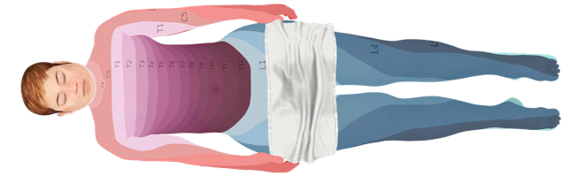The absence of competent tools to visualize and learn the materials

3D simulation approach:

Efficiently learning the nervous system requires an integrative approach to activities in which they can be facilitated through traditional methods, virtual dissection, 3D anatomy, and physiology simulation platforms.

Interelattedly, understanding the anatomical and physiological notions of both the central and peripheral nervous systems involves more than just visualization. For example, to intellectually examine the central nervous system functions, students can rely on a 3D simulation tool to assist users in identifying which spinal nerve corresponds to each dermatome. Also, because the nerve system of the cerebral cortex might be challenging to visualize through the naked eye, some 3D simulation tools can help magnify nervous structures for better observation.

Furthermore, selected 3D visualization and simulation platforms provide annotated nervous structures that can assist in memorizing the structures better.

More importantly, 3D simulation presents insightful clinical applications to medical students. For example, determining the pain stemming from specific nerves or cortex regions requires an in-depth inspection of the comprehensive sensory and motor distribution of spinal nerves and 3D simulation enables such visualization.

III. Kinesiology/Muscles Movements

|  |  |
| --- | --- |
| Compared to other medical sciences, kinesiology is often considered a “less challenging” discipline. Even so, 27.00% of the surveyed educators responded that muscle movement is one of the physiology concepts that students have trouble with visualizing. | **What are some challenges you’re facing in your kinesiology teaching?** |

Interestingly, a separate survey by HAPS reveals that 46.70% of the surveyed educators believe that students’ lack of anatomy foundation prevents them from successfully learning Kinesiology. The difficulty of visualizing anatomical movements is also reported by 6.70% of the respondents.

46.7

%

20.0

%

26.7

%

6.7

%

Students lack of anatomy foundation

Students lack of motivation

Lack of instructional resources

Difficulty in visualizing movements

This data correlates with findings found in a study published by Youngstown State University - which acknowledges that the difficulty of learning kinesiology lies in the lack of basis for understanding how the body system works.

Specifically, the study concluded that one of the barriers preventing students from successfully learning kinesiology is the vast amount of information pertaining to muscles and their function. To truly understand the basis of kinesiology - in addition to identifying muscles - students must also recognize the impact (and functions) of muscles on the anatomical movements.

3D simulation approach:

With the subject heavily emphasizing anatomical movements, it’s crucial to integrate technology into the learning activities that allow students to accurately visualize how joints, bones, and muscles work together to generate motions.

For instance, a research study conducted at Université Claude Bernard Lyon, Villeurbanne survey introduced an integrative approach to teaching kinesiology with both 2D and 3D animation. The goal of this approach was to test the effectiveness of 3D animation in teaching kinesiology for first-year undergraduate students. To experiment with this approach, one of the two groups of students was given lectures in which the PowerPoint slides were embedded with 3D animation, while another group was given lectures with 2D drawings only.

According to the findings, 3D digital animation were reported to be more effective as instructional materials in allowing students to deeply understand spatial relationships between anatomical structures. 3D simulation can assist in visually interpreting the mechanism behind anatomical movements. Specifically, it allows for visualization of how the movements are generated by joints, muscles, and bones.

The simulation of the movements can also help differentiate the antagonistic pairs, as well as different types of anatomical movements;

* 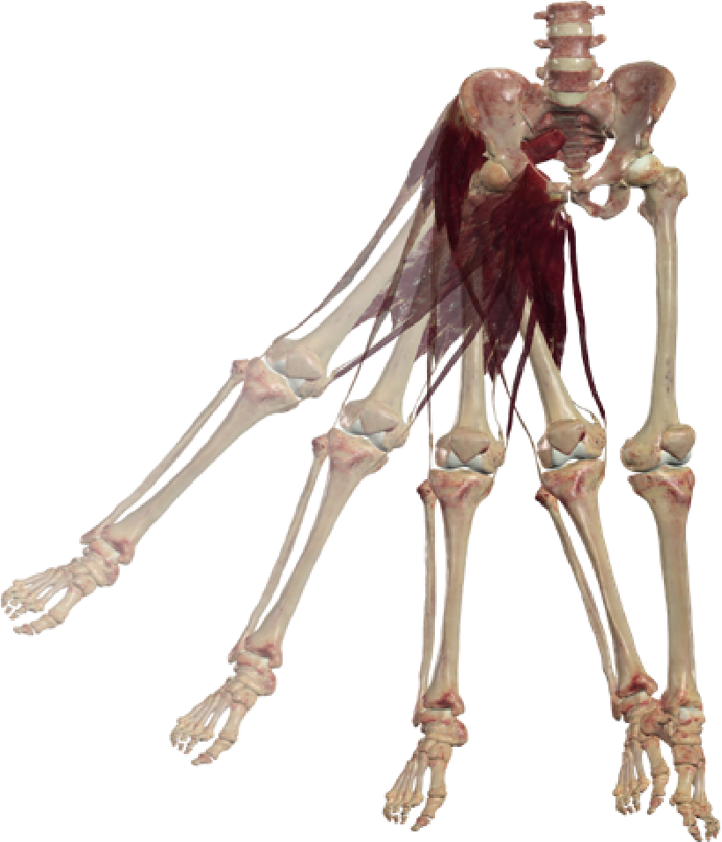flexion/extension
* abduction/adduction
* internal/external rotation
* protraction/retraction
* elevation/depression directions

# Conclusion

A crucial part of learning gross anatomy, 3D modeling and simulation enable both educators and students to engage with the anatomy and physiology materials in the most possible interactive manner. In addition to providing in-depth visualization of the human anatomy, it also offers visual insights into human physiology - which can’t be done with physical cadavers.

Most importantly, 3D modeling and simulation technology simplifies the most complicated learning concepts by turning them into reality, allowing trainers to gain real-world clinical knowledge.

Visualize Life With Anatomage Table: Concepts to Reality

The goal of science is to allow us to discover, study and understand life to preserve, maintain, and further it.

And to understand life, we rely on the information that the human body offers us - from its structures, systems, and functions. Learning anatomy and physiology helps us to absorb these details academically.

Yet, the human body contains tremendous information that can’t be digested efficiently using one medium. Whether it’s books, cadaveric dissections, virtual anatomy, or physiology simulation, many approaches aim to one goal: turning learning concepts into reality.

Fostering this idea, Anatomage Table is developed to transform Anatomy and Physiology concepts to reality by helping users visualize “life” better.

From when life begins to when the heart beats, the body moves, functions, and suffers disease, the Anatomage Table captures the essence of life and translates it into technology that enables users to visualize, study and understand life better.

Recently, [**Table 8**](https://www.anatomage.com/table8/) - the Anatomage Table’s latest software - was released that makes it possible for users to interact with living anatomy and physiology.

Academic advantages of Anatomage

Table 8’s 3D visualization & simulation:

## Spatial Relationship

* Enables a better visualization of spatial relations between anatomical structures
* Improves spatial learning ability for students
* Assists in understanding and reading of MRI, CT and other imaging scans

## Physiology Conceptualization

* Allows for visually conceptualizing challenging physiology concepts that can’t be obtained through cadaveric dissections
* Enhances the understanding of pathophysiological responses in a human body
* Provides accurate and realistic scientific insights into how the living human body acts, functions and responds

## Clinical Applications

* Assists in inspecting pathological responses from real human bodies
* Enables access to clinical cases that contains common and rare diseases
* Allows for interaction and manipulation with MRI/CT scans

## Interactive Learning

* Promotes an interactive learning space where 3D visualization and simulation is accessible
* Encourages students to collaborate with each other to explore the wonders of the human body
* Allows students to interact with living human bodies

## Accurate Perception

* Makes it possible for students to visualize accurate human anatomy content
* Facilitates interacting with living anatomy and physiology
* Allows for a highly insightful and accurate perspective into how anatomical systems work with each other

## Cost Efficiency

* Enables institutions to reduce costs from cadaver maintenance
* Offers annual software upgrades that contain the most applicable anatomy content and simulation tools
* Helps institutions establish technological leadership within their community, improving student application rates

# References

Rebekah M. Lieu, Andrew Gutierrez and Justin F. Shaffer et al. Student Perceived Difficulties in Learning Organ Systems in an Undergraduate Human Anatomy Course. HAPS EDUCATOR (2018) <https://files.eric.ed.gov/fulltext/EJ1227929.pdf>

R. Aswini Dutt, Rashmi Jain , Shobith Bangera. An integrated simulation-based early clinical exposure module in cardiovascular physiology. Scientific Scholar on behalf of Indian Journal of Physiology and Pharmacology [https://ijpp.com/an-integrated-simulation-based-early-clinicalexposure-module-in-cardiovascular-physiology/](https://ijpp.com/an-integrated-simulation-based-early-clinical-exposure-module-in-cardiovascular-physiology/)

**About Anatomage**

**Anatomage Inc.**

**For more information**

As a market leader in medical virtualization technology, Anatomage enables an ecosystem of 3D

anatomy hardware and software, allowing users to visualize anatomy at the highest level of accuracy.

Established in both education and healthcare industries, Anatomage is transforming standard

anatomy learning, medical diagnosis and treatment planning through its highly innovative products.

Thomas Rd

3350

Santa Clara, CA 95054

**www.anatomage.com**

info@anatomage.com

(408) 885-1474

Michele L. McCarroll, Rachael J. Pohle-Krauza, and Jennifer L. Martin. Active learning in the classroom: a muscle identification game in a kinesiology course. Summa Health System. [https:// journals.physiology.org/doi/pdf/10.1152/advan.00013.2009](https://journals.physiology.org/doi/pdf/10.1152/advan.00013.2009)

Samy A. Azer, Sarah Azer. 3D Anatomy Models and Impact on Learning: A Review of the Quality of the Literature. Science Direct. Health Profession Education (2016) [https://www.readcube.com/ articles/10.1016%2Fj.hpe.2016.05.002](https://www.readcube.com/articles/10.1016%2Fj.hpe.2016.05.002)

NAME OF VENDOR

ADDRESS

CONTACT PERSON

TELEPHONE NUMBER

First, the undersigned having carefully examined the **Bid for Anatomage Table Associated Accessories and Training** in accordance with the specifications of the proposal, submits this proposal and agrees to furnish and perform the specified **Anatomage Table Associated Accessories and Training** for the School District of the City of Erie for the amounts indicated on page 1 of the Bid.

Second, the undersigned agrees to enter into a written contract to furnish such materials and services as required in the proposal specifications.

Third, the following quotation prices are listed as firm for a period of __________ after the due date of this request for bid.

**NOTE: The School District of the City of Erie will not be liable and will not pay for any applicable costs not included and detailed in the Bid.**

Signature

Date

Title or Office

**INSTRUCTIONS FOR NON-COLLUSION AFFIDAVIT**

1. This Non-Collusion Affidavit is material to any contract awarded pursuant to this RFP. According to the Pennsylvania Antibid-Rigging Act. 73 P.S. 1611 et seq. governmental agencies may require Non-Collusion Affidavits to be submitted together with bids or RFP’s.
2. This Non-Collusion Affidavit must be executed by the member, officer or employee of the Vendor who makes the final decision on prices and amounts quoted in the RFP.
3. Bid/RFP rigging and other efforts to restrain competition, and the making of false sworn statements in connection with the submission of bids or RFP’s are unlawful and may be subject to criminal prosecution. The person who signs the affidavit should examine it carefully before signing and assure himself/herself that each statement is true and accurate, making diligent inquiry, as necessary, of all other persons employed by or associated with the Vendor with responsibilities for the preparation, approval, or submissions of the RFP.
4. In case of a RFP submitted by a joint venture, each party to the venture must be identified in the RFP/Bid documents, and an affidavit must be submitted separately on behalf of each party.
5. The term “complementary RFP” as used in the Affidavit has the meaning commonly associated with that term in the bidding/RFP process, and includes the knowing submission of RFP’s higher than the RFP of another Vendor, any intentionally high or noncompetitive RFP, and any other form of RFP submitted for the purpose of giving a false appearance of competition.
6. Failure to file an Affidavit in compliance with these instructions will result in disqualification of the RFP.

**NON-COLLUSION AFFIDAVIT**

**BID ON – Anatomage Table/Associated Accessories and Training**

State of

County of

I state that I am of

(Title) (Name of Vendor)

and that I am authorized to make this affidavit on behalf of my company, and its owners, directors, and officers, I am the person responsible in my company for the price(s) and the amount of this Request for Proposal (RFP).

I state that:

1. The price(s) and amount of this RFP have been arrived at independently and without consultation, communication, or agreement with any other Vendor.
2. Neither the price(s) nor the amount of this RFP, and neither the approximate price(s) nor the approximate amount of this RFP, have been disclosed to any other Vendor, and they will not be disclosed before the RFP submission to The School District of the City of Erie.
3. No attempt has been made or will be made to induce any Vendor or person to refrain from submitting an RFP to The School District of the City of Erie, or to submit an RFP higher than this RFP, or to submit any intentionally high or noncompetitive RFP or other form of complementary RFP.
4. The RFP of my company is made in good faith and not pursuant to any agreement or discussion with or inducement from, any Vendor or person to submit a complementary or other noncompetitive RFP.
5. , its affiliates, subsidiaries, officers, directors and employees

(Name of my Company)

are not currently under investigation by any governmental agency and have not in the last four years been convicted or found liable for any act prohibited by State or Federal law in any jurisdiction, involving conspiracy or collusion with respect to submitting an RFP to any public entity, except as follows:

I state that understand and acknowledges that the above

(Name of my Company)

representations are material and important, and will be relied on by The School District of the City of Erie when recommending for award the agreement for which this RFP is submitted, I understand and my company understands that any misstatement in this affidavit is and shall be treated as fraudulent concealment from the School District of the City of Erie of the true facts relating to the submission of RFP’s for this agreement.

Signature of Authorized Person

(Print Name of Authorized Person and Company Position)

Sworn to and subscribed before

Me this day of

, 20

(Notary Public) (My Commission Expires)